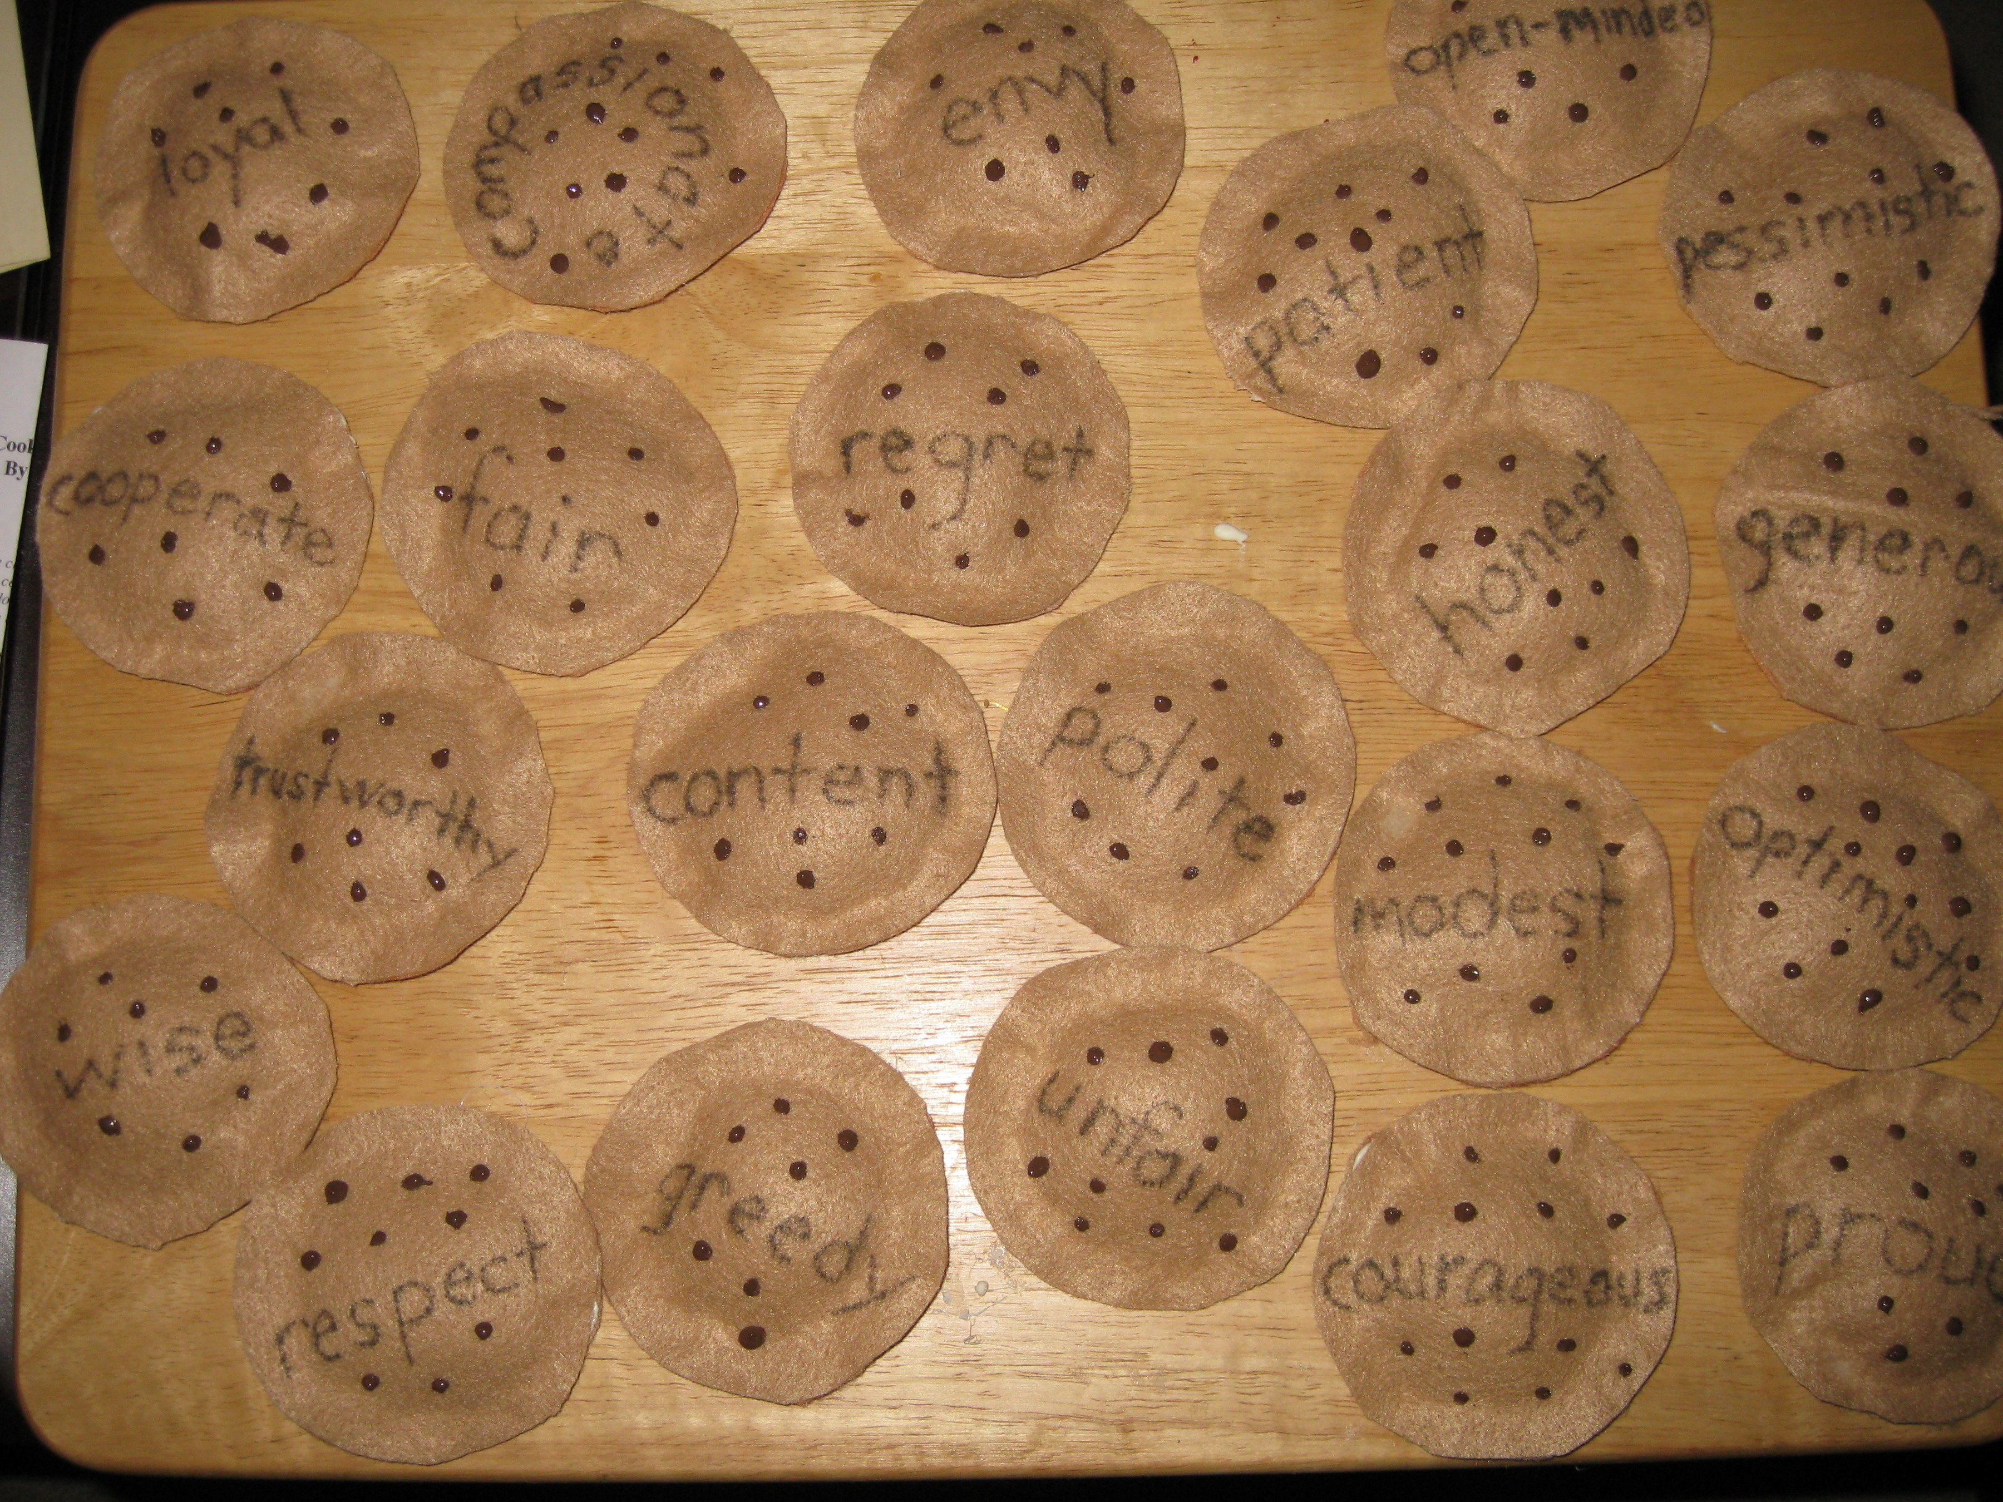
Cookies Bite-Size Life Lessons
By Amy Krouse Rosenthal

Cooperate means, How about you add the chips while I stir?
Patient means waiting and waiting for the cookies to be done.
Proud means, My chin is high, and I sure do like the way my cookies turned out.
Modest means you don’t run around telling everyone you make the best cookies, even if
you know it to be true.
Respect means offering the very first cookies to your grandmother.
Trustworthy means, if you ask me to hold your cookies until you come back, when you
come back, I will still be holding your cookie.
Fair means, you get a bite, I get a bite, you get a big bite, I get a big bite.
Unfair means, you get a bite, and now I get the rest.
Compassionate means, don’t worry, it’s okay. You can have part of my cookie.
Greedy means taking all the cookies for myself.
Generous means offering some to others.
Pessimistic means, how awful, how absolutely dreadful-I have only half my cookie left.
Optimistic means, this is great – I still have half my cookie left.
Polite means, excuse me, can you please pass the cookies? Thank you.
Honest means, I have to tell you something. The butterfly didn’t really take the cookie-
I took the cookie.
Courageous means, it was not easy for me to tell you that I took the cookie, but I took a
deep breath…and made the words come out.
Envy means, I can’t stop looking at your cookie out o the corner of my eye – it looks so
much better than my cookie. Boy, I wish it were mine and not yours.
Loyal means that even though the new person has a much bigger cookie, I’m sticking
by you and your little cookies because you’re my very best friend.
Open-Minded means, I’ve never seen cookies like that before, but, uh, sure, I’ll try one.
Regret means, I really wish I didn’t eat so many cookies.
Content means sitting on the steps – just you, me, and a couple of cookies.
Wise means, I used to think I knew everything about cookies, but now I realize I know
about one teeny chip’s worth.

Jacquie Porter, the new Director of Early Childhood, in Austin ISD, read this book to PreK and PPCD teachers at the salad supper. She has used this book with her students and with teachers. She also showed us the felt chocolate chip cookies that she made with the 22 words written on them. She cut out 44 felt circles, wrote one of the words on half the circles, put a pinch of rice in the middle of each and hot glued the layers together. She kept them in the classroom cookie jar and pulled one out each week for her “character-building” trait of the week.

